14th September 2016

New Miss YOKOHAMA elected in Switzerland

The traditional beauty pageant which is organised by YOKOHAMA Switzerland every year celebrated its 15th edition at the weekend. This time the 19 years old Romana Möckli took the crown from the former Miss YOKOHAMA Roxane Baumann.

Prior to the final contest, a casting for the finalists took place and 15 contenders had been selected for the Grand finale.

The contestants were interviewed and paraded in front of an experienced panel of judges which this time included representatives of YOKOHAMA Switzerland Mr. Reto Wandfluh, the former Miss YOKOHAMA Roxane Baumann, Miss Switzerland 2010 Kerstin Cook, Sales Director for Honda Zurich Mr Daniel Venzin, and the Chief Editor of Autosprint CH Mr Stefan Donat.

Romana Möckli will now be engaged in numerous events on behalf of YOKOHAMA which will include attending next year’s Geneva Motor Show as well as other public appearances.


Miss YOKOHAMA Finalists Photo Maren Kindler

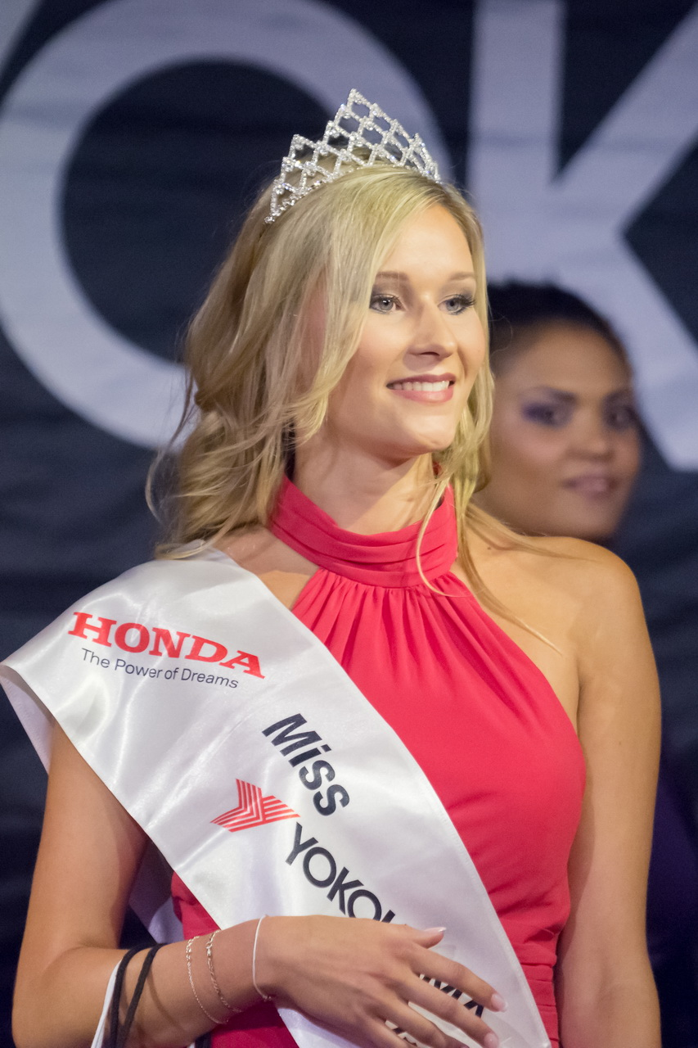
Miss YOKOHAMA Switzerland Romana Möckli, photo Martin Walder

